**AI LAB ASSIGNMENT 2**

Name: Syed Muzzamil Waseem

SID: 11067

CID: 110089

Date: 14/08/2022

**QUESTION 1:**

Q1. Perform Histogram Equalization on the following image

**CODE:**

import cv2

import numpy as np

from matplotlib import pyplot as plt

img = cv2.imread('C:\\Users\\muxxa\\OneDrive\\Desktop\\img.png',0)

hist,bins = np.histogram(img.flatten(),256,[0,256])

cdf = hist.cumsum()

cdf_normalized = cdf * hist.max()/ cdf.max()

plt.plot(cdf_normalized, color = 'b')

plt.hist(img.flatten(),256,[0,256], color = 'r')

plt.xlim([0,256])

plt.legend(('cdf','histogram'), loc = 'upper left')

plt.show()

cdf_m = np.ma.masked_equal(cdf,0)

cdf_m = (cdf_m - cdf_m.min())*255/(cdf_m.max()-cdf_m.min())

cdf = np.ma.filled(cdf_m,0).astype('uint8')

img2 = cdf[img]

**OUTPUT:**

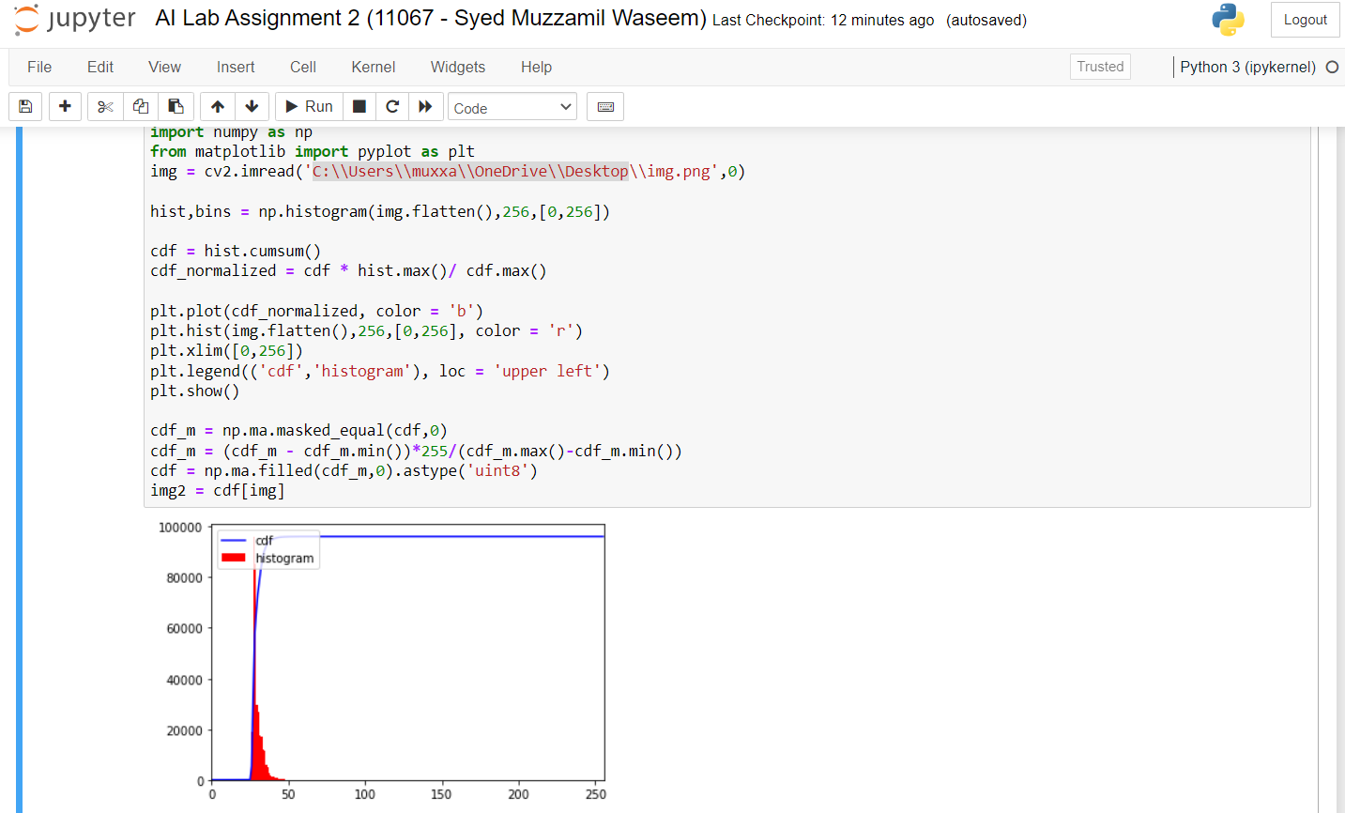

**QUESTION 2:**

Q2.Write a program to implement linear regression on following data:

x = [5,7,8,7,2,17,2,9,4,11,12,9,6]

y = [99,86,87,88,111,86,103,87,94,78,77,85,86]

**CODE:**

import matplotlib.pyplot as plt

from scipy import stats

x = [5,7,8,7,2,17,2,9,4,11,12,9,6]

y = [99,86,87,88,111,86,103,87,94,78,77,85,86]

slope, icp, r, p, std_err = stats.linregress(x, y)

def func(x):

return icp+slope * x

model = list(map(func, x))

plt.scatter(x, y)

plt.plot(x, model)

plt.show()

**OUTPUT:**

